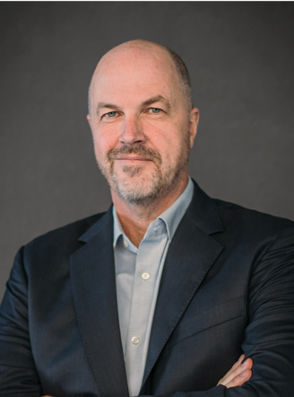
Biography
Michael Claeys
Professor
Catalysis Institute & DSI-NRF Centre of Excellence in
Catalysis (c*change), University of Cape Town

Professor Claeys obtained his PhD (with distinction) in Fischer-Tropsch catalysis at the University of Karlsruhe, Germany, in 1997 and then joined the Catalysis Institute at the University of Cape Town. Here he was instrumental in establishing a large research activity with focus on Fischer-Tropsch catalysis, a technology, which lies at the heart of South Africa’s synthetic fuels and chemicals industry and which is playing an increasingly important role in the production of green future fuels via Power-to-X processes. Other research interests include the preparation and characterisation of nano materials and their use in catalytic applications, as well as the development of catalysts and novel instrumentation for characterisation of catalysts at working conditions. Professor Claeys has published extensively on these topics, he holds a number of patents and he has been awarded an A-rating (‘leading international researcher’) by the National Research Foundation of South Africa.
A large portion of his research is conducted in conjunction with industrial partners, in particular a longstanding industrial collaboration with Sasol R&D. Professor Claeys is the Director of the DSI-NRF Centre of Excellence in Catalysis, c*change, a large virtual and multidisciplinary Centre, where he also acts as the Manager of the Scientific Synthesis Gas Programme, which includes processes of catalytic valorization of CO₂. He is currently involved in various large PTL projects including the BMBF-funded CARE-O-SENE consortium and the South African national CoalCO₂-to-X flagship programme. Moreover, he is the founding Chairperson of the Syngas Convention, a triennial international meeting on synthesis gas technologies held in Cape Town.

